Infrastructure as a Service in Microsoft Azure

The ability to create a virtual machine on demand, whether a standard image or from one you supply, can be very useful. This approach, commonly known as Infrastructure as a Service (IaaS), is what Azure Virtual Machines provides.

To create a VM, you specify which VHD to use and the VM's size. You then pay for the time that the VM is running. You pay by the minute and only while it's running, though there is a minimal storage fee for keeping the VHD available. Azure offers a gallery of stock VHDs (called "images") that contain a bootable operating system to start from. These include Microsoft and partner options, such as Windows Server and Linux, SQL Server, Oracle and many more. You're free to create VHDs and images and then upload them yourself. You can even upload VHDs that contain only data and then access them from your running VMs.

This quite general approach to cloud computing can be used to address many different issues:

* **Dev/Test** - You might use them to create an inexpensive development and test platform that you can shut down when you've finished using it. You might also create and run applications that use whatever languages and libraries you like. Those applications can use any of the data management options that Azure provides, and you can also choose to use SQL Server or another DBMS running on one or more virtual machines.
* **Move Applications to Azure (Lift-and-shift)** - "Lift-and-shift" refers to moving your application much like you'd use a forklift to move a large object. You "lift" the VHD from your local datacenter, and "shift" it to Azure and run it there. You will typically have to do some work to remove dependencies on other systems. If there are too many, you may choose option 3 instead.
* **Extend your Datacenter** - Use Azure VMs as an extension of your on-premises datacenter, running SharePoint or other applications. To support this, it's possible to create Windows domains in the cloud by running Active Directory in Azure VMs. You can use Azure Virtual Network to tie together your local And Azure networks.

In this lab, you will learn how to create virtual machines using Azure Portal.

Creating a Virtual Machine using Azure Portal

In this task you will create a Virtual Machine in Azure Portal.

1. Sign in to the [Azure Portal](https://portal.azure.com/).
2. On the Left Side bar, click **+ NEW** and then click on **See all**.

[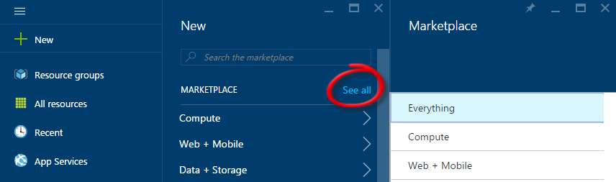](https://github.com/opsgility/DevCamp/blob/master/HOL/create-virtual-machine/images/click-new-and-everything.png?raw=true)

*Creating a VM*

1. Click **Compute** and then click the **Windows Server** tile.

[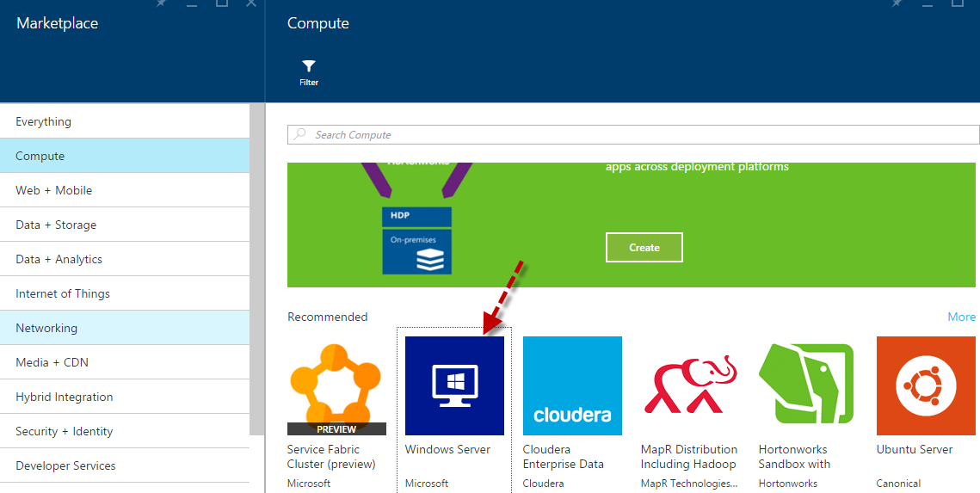](https://github.com/opsgility/DevCamp/blob/master/HOL/create-virtual-machine/images/creating-compute-vm-winserver.png?raw=true)

*Creating a VM - Click Virtual Machines then the Windows Server tile*

1. A new blade opens with the different images available for **Windows Server**. Find and click **Windows Server 2012 R2 Datacenter**.

[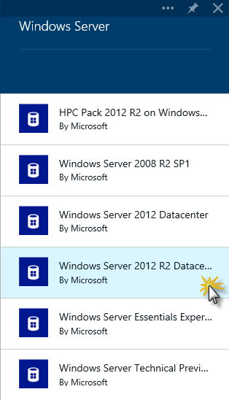](https://github.com/opsgility/DevCamp/blob/master/HOL/create-virtual-machine/images/creating-vm-select-image.png?raw=true)

*Creating a VM - Select the image to use*

1. In the **Windows Server 2012 R2 Datacenter** blade, Select **'Resource Manager'** from dropdown **select a deployment model**, and then click **Create**.

[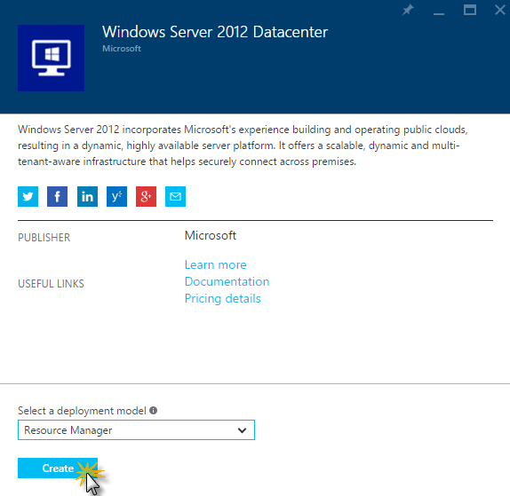](https://github.com/opsgility/DevCamp/blob/master/HOL/create-virtual-machine/images/creating-vm-confirm-image.png?raw=true)

*Creating a VM - Click Create to confirm the use of this image*

1. On the **Create Virtual Machine** blade that opens, enter:
   * **Name**: virtual machine name (e.g. testvm)
   * **User Name**: administrator user for the virtual machine (e.g. adminUser)
   * **Password**: unique password for the administrator account
   * **Subscription**: Select if you have multiple subscriptions
   * **Resource**: New or Existing (e.g. create-vm)
   * **Location**: select the location for the virtual machine. (e.g. West US)

[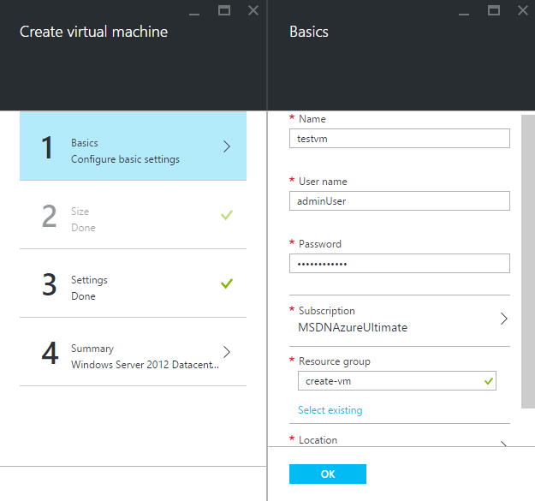](https://github.com/opsgility/DevCamp/blob/master/HOL/create-virtual-machine/images/create-vm-resource-basic-config.png?raw=true)

*Creating a VM - Basic Configuration*

* + **Size**: select the size of virtual machine needed. (Select **See All** for checking all sizes and details)

[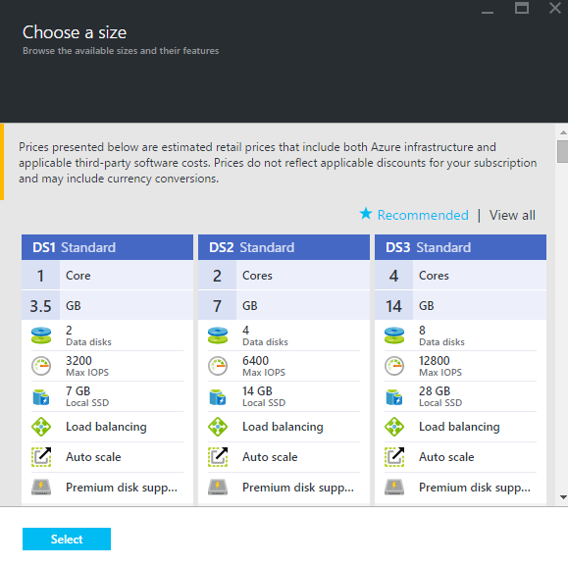](https://github.com/opsgility/DevCamp/blob/master/HOL/create-virtual-machine/images/create-vm-resource-choose-size.png?raw=true)

*Creating a VM - Types of Sizes*

* + **Disk Type**: select the disk size. (e.g. Standard/Premium(SSD))
  + **storage account**: storage account details(if existing select the storage account at specified location or create new)
  + **virtual network**: virtual network for the virtual machine to create
  + **Subnet**: subnets under one Virtual network
  + **Public IP address**: public IP address

[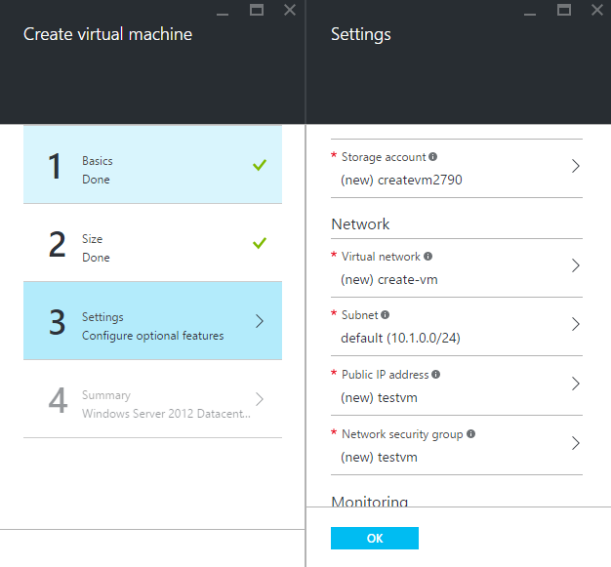](https://github.com/opsgility/DevCamp/blob/master/HOL/create-virtual-machine/images/create-vm-resource-settings-config.png?raw=true)

*Creating a VM - Settings*

* + **Summary**: virtual machine summary details before you click on create.

[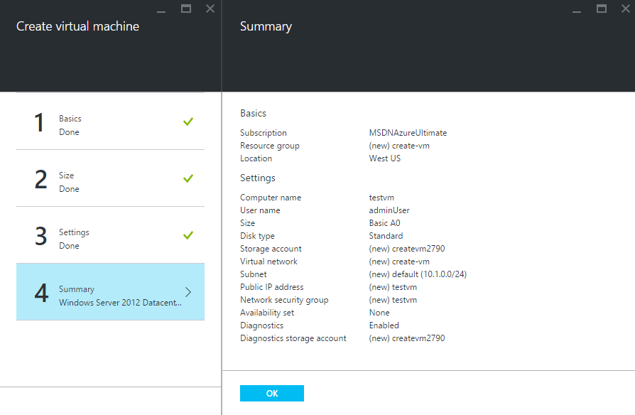](https://github.com/opsgility/DevCamp/blob/master/HOL/create-virtual-machine/images/create-vm-summary.png?raw=true)

*Creating a VM - Summary*

**Note:** Premium storage, available for DS-series virtual machines in certain regions. For details, see [Premium Storage: High-Performance Storage for Azure Virtual Machine Workloads](http://azure.microsoft.com/en-us/documentation/articles/storage-premium-storage-preview-portal/).

1. Click **OK**.
2. The VM will start being created. You can monitor the creation progress on the **Notifications**. As this can take a few minutes, this task ends here.

[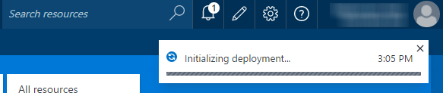](https://github.com/opsgility/DevCamp/blob/master/HOL/create-virtual-machine/images/creating-vm-monitor-progress-on-the-notifi.png?raw=true)

*Creating a VM - Monitor progress in the Notifications Hub*

**Note:** After the VM is created, the Virtual Machine blade will open. A pin for the VM (e.g. azureVM) is also added to the **Startboard**. You can use it to access the VM.

[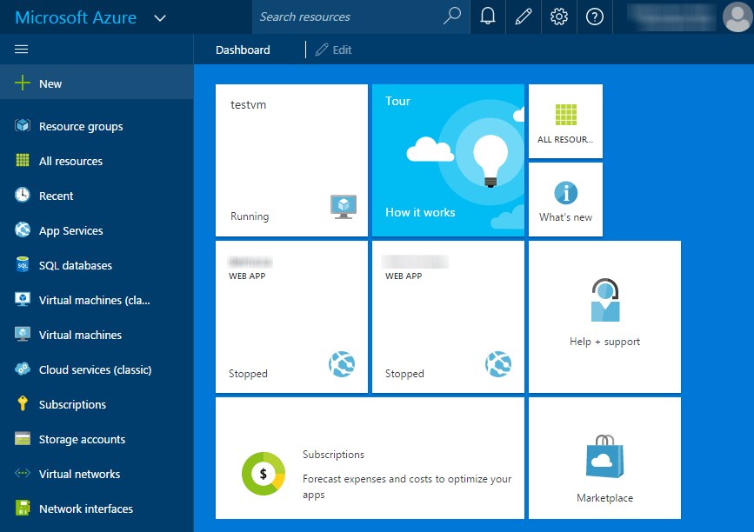](https://github.com/opsgility/DevCamp/blob/master/HOL/create-virtual-machine/images/creating-vm-pin-in-startboard-after-creation.png?raw=true)

*Creating a VM - A pin was created in the Startboard*

Once the virtual machine has been created you can attach new or existing data disks to the Virtual Machine. See [About Virtual Machine Disks in Azure](https://msdn.microsoft.com/library/azure/dn790303.aspx) for more information.

[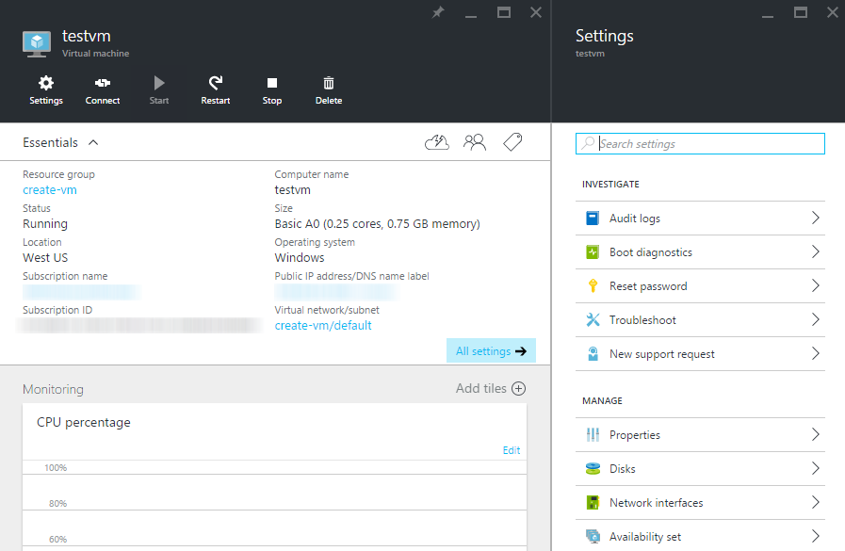](https://github.com/opsgility/DevCamp/blob/master/HOL/create-virtual-machine/images/create-vm-details-created.png?raw=true)

*Virtual Machine details after Creation*

*END OF DOCUMENT*